TIER — Usage Snapshot
12-June to 20-July 2026

In the first several weeks of tracked use, TIER was opened in 364 sessions with ~141 individual users. This note summarises which countries are being modelled, what interventions decision-makers are exploring, and how deeply people are engaging.
Engagement
Around one in five sessions went beyond a quick look to actually build and compare scenarios. Those users returned to the comparison view roughly three times on average — highlighting that the people who engage are likely iterating over multiple scenarios.
Countries being modelled
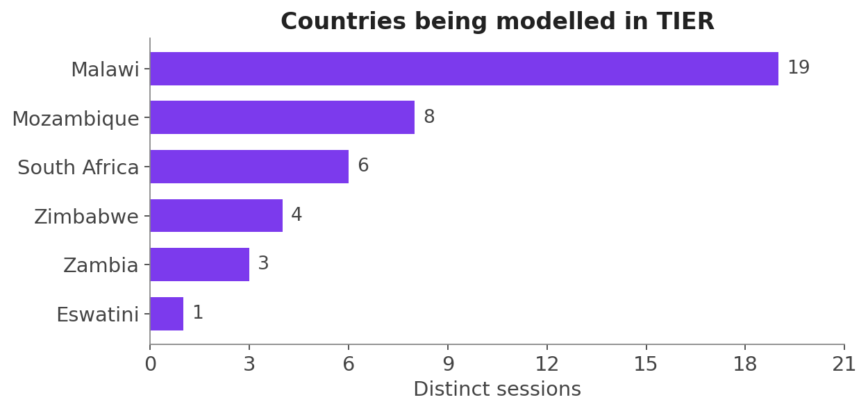
Counting unique active sessions per country (i.e sessions where scenarios were adapted and results were reviewed, as opposed to merely previewing the app), engagement was led by Malawi, with Mozambique and South Africa next, then Zimbabwe, Zambia and Eswatini.
Distinct sessions = unique sessions that modelled each country at least once. A session that modelled several countries is counted under each.
Botswana excluded — currently it is the tool's default landing country. As such, many of the country counts may reflect opening the tool rather than active usage. Future iterations will aim to account for this.
What decision-makers are exploring
Considers which interventions are being adjusted and it what direction. Generally:
- Scaling up Lenacapavir is the single most-adjusted intervention, oral prep is being considered in both scale-up and scale-down scenarios.
- Scaling up 6-month dispensing over 3-month dispensing is being considered.
- Infant prophylaxis and routine viral-load / CD4 monitoring were mostly scaled up .
- Condoms, general facility-based testing and VMMC were more often scaled back.
